1. IAM USER CASE: Creation of IAM account to have Full access to S3 service

Navigate to Security, Identity and Compliance -> IAM

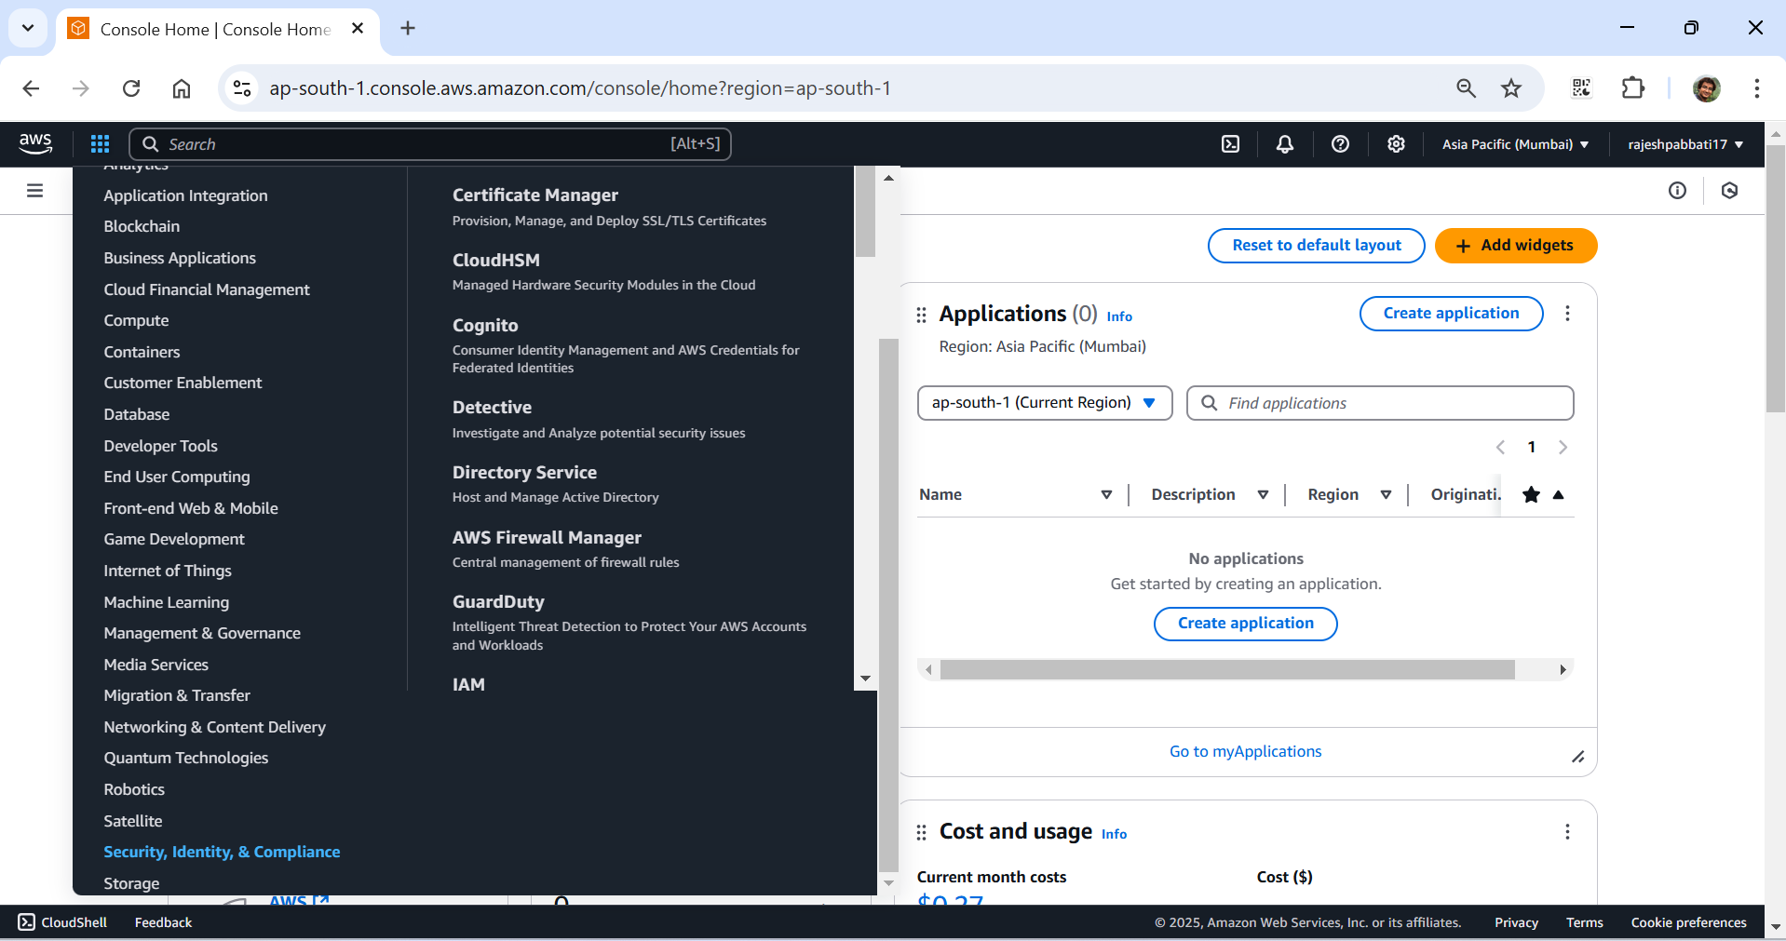

Click on Users

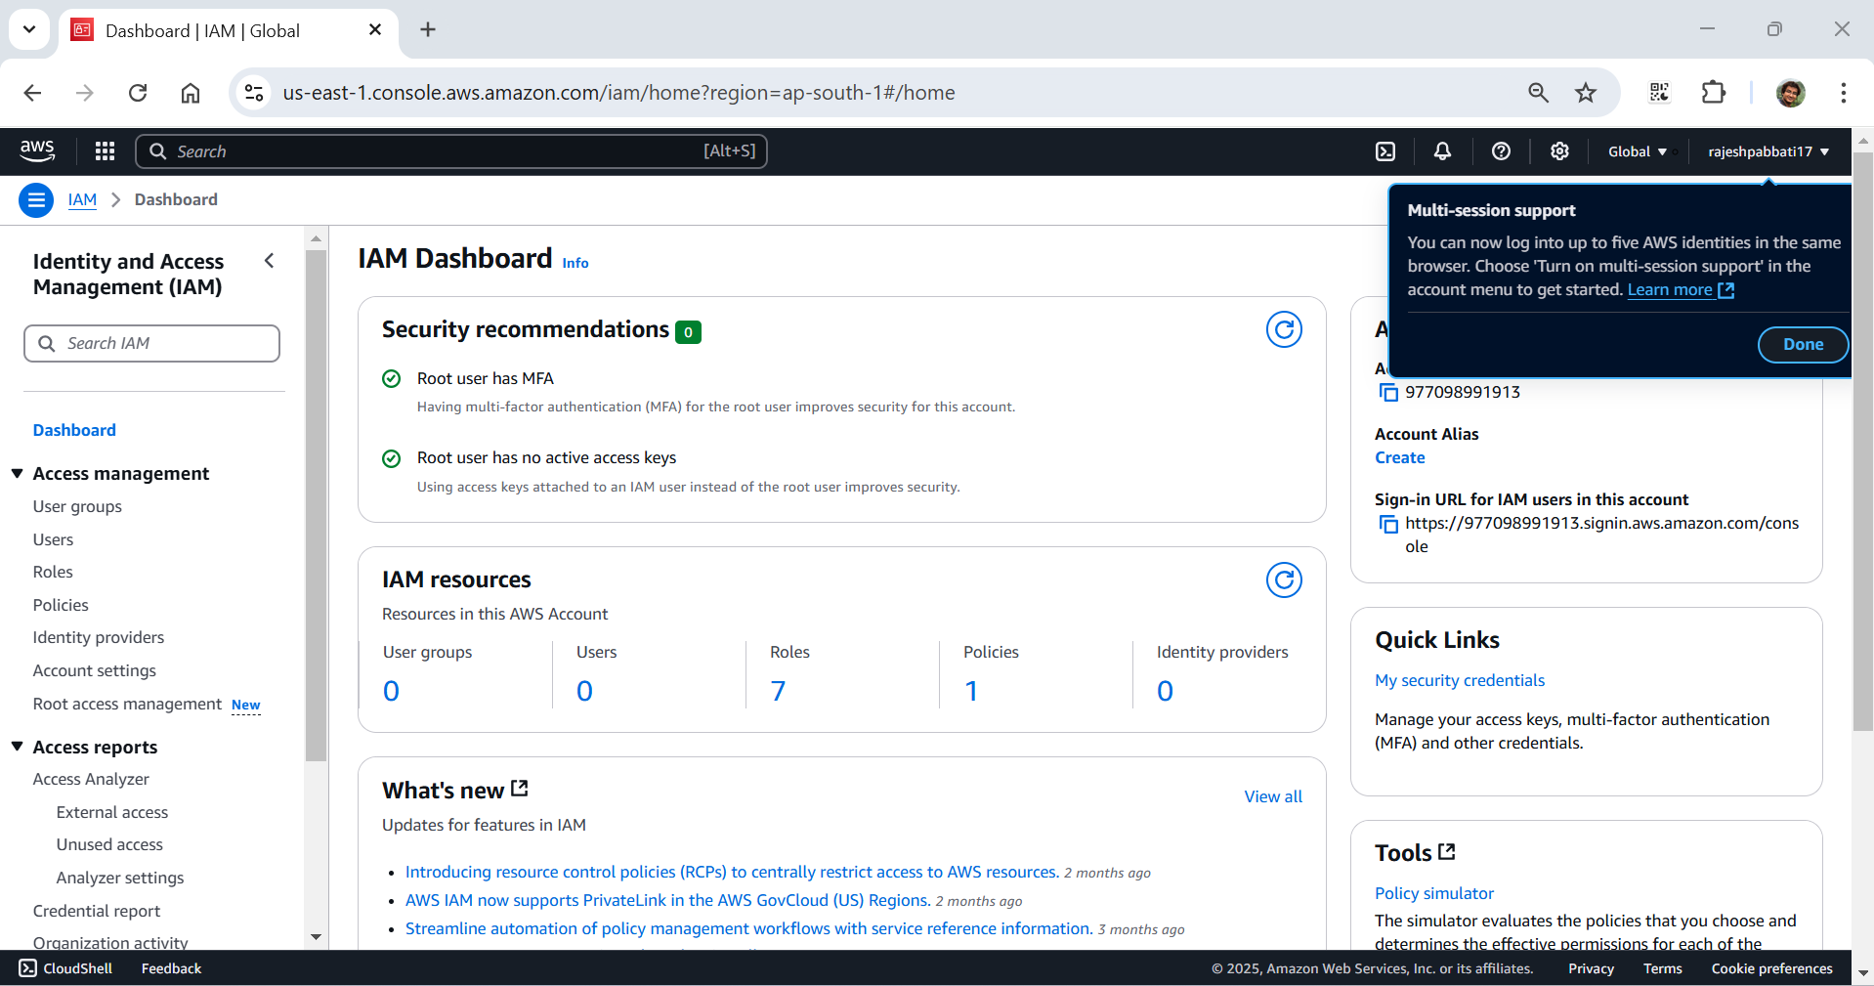

Click on Create user

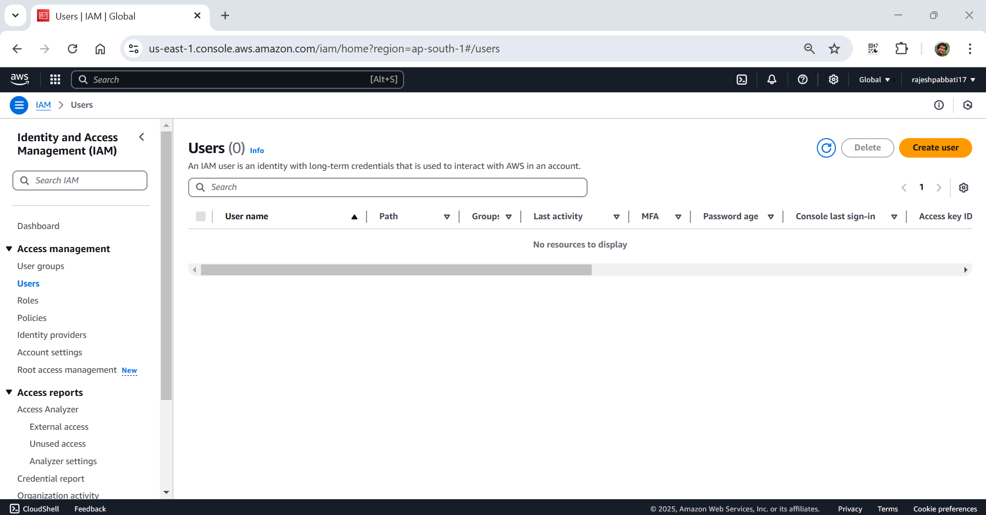

Enter user name as S3user

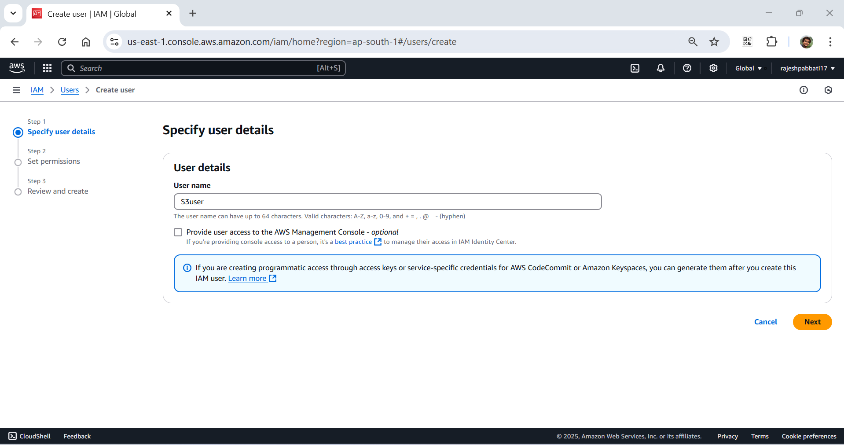

Tick the checkbox “Provide user access to the AWS Management Console”

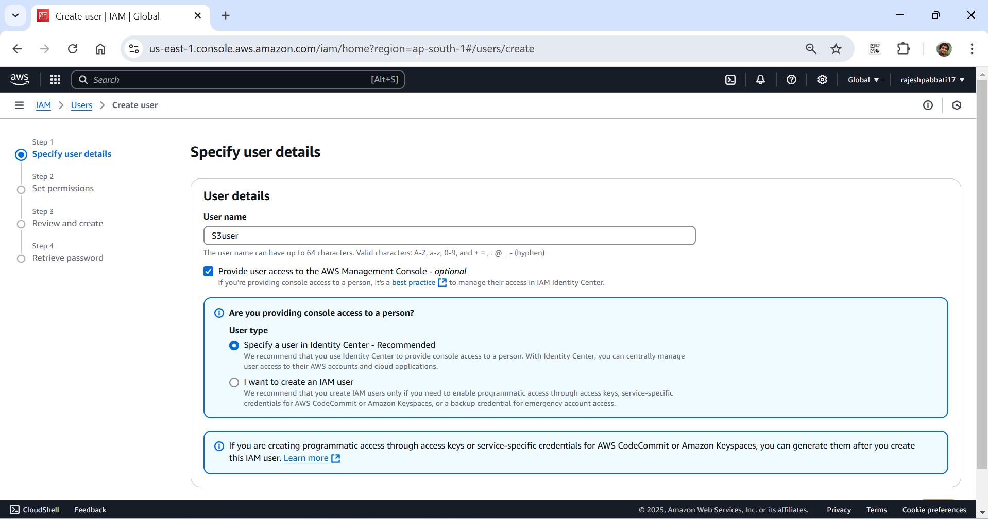

Select I want to create an IAM user option

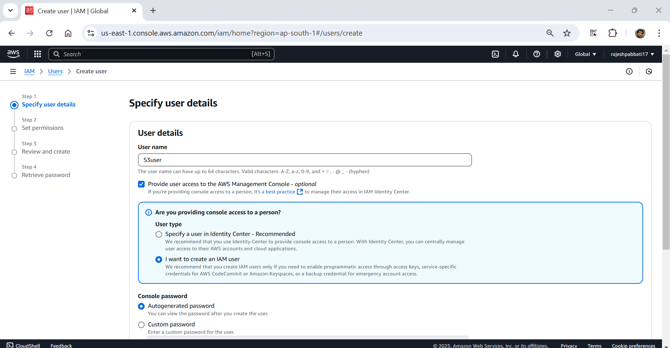

Select Custom password and give password as your wish

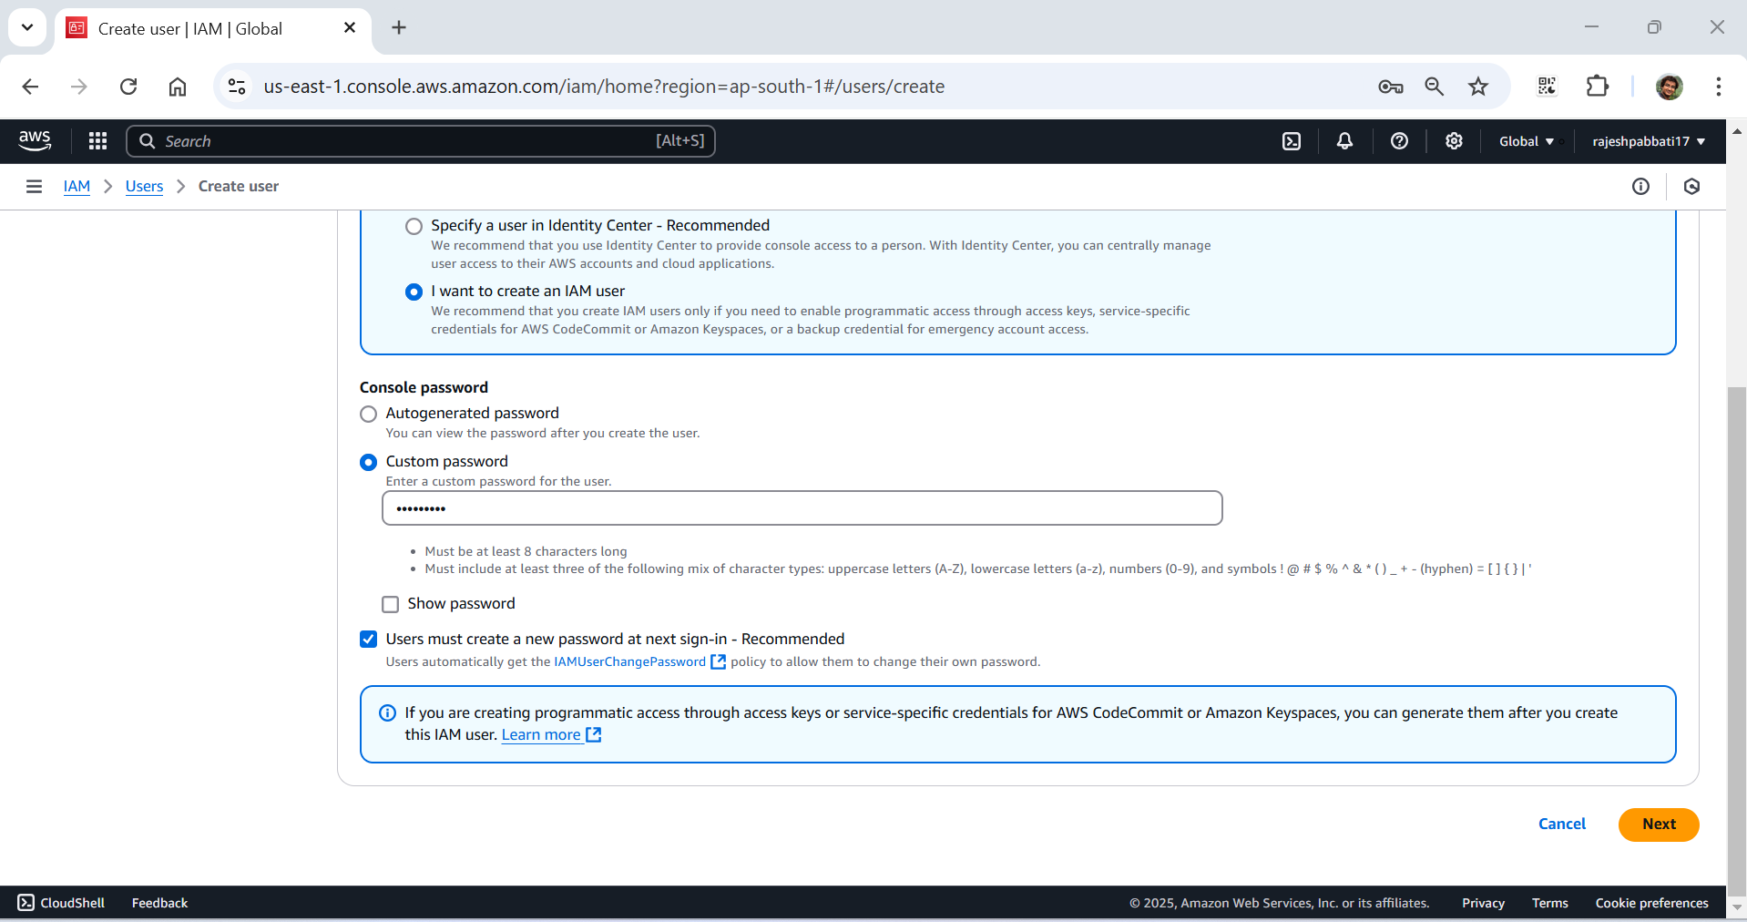

Untick the checkbox “User must create a new password at next sign-in” and click next

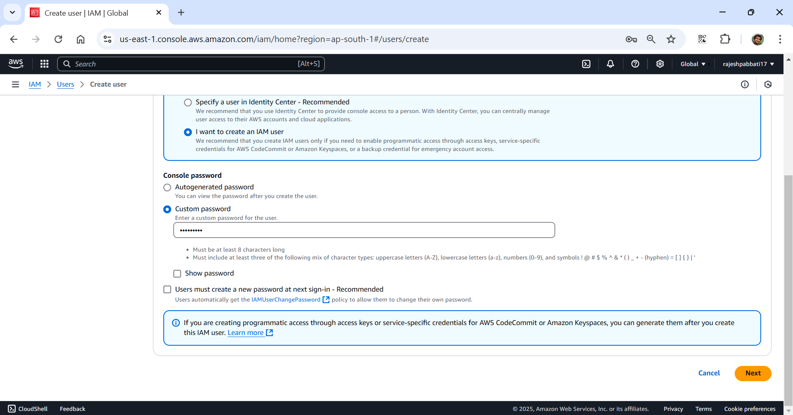

Set permission by selecting appropriate option

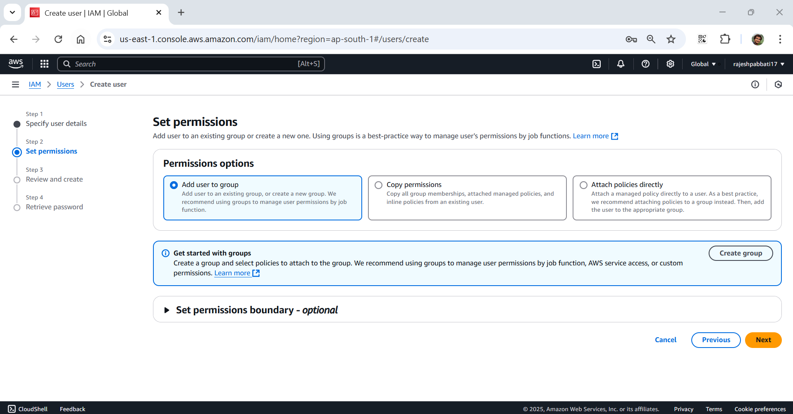

Select Attach policies directly

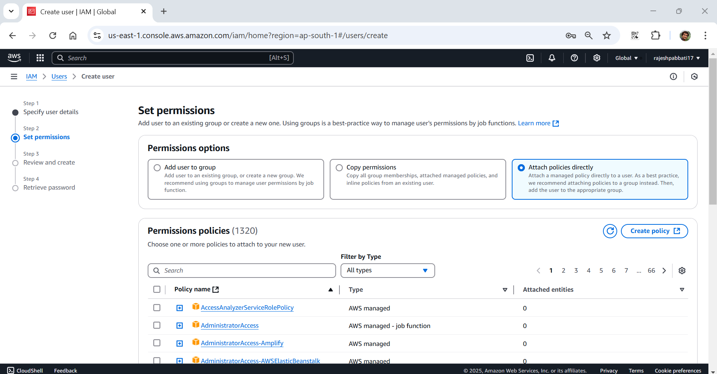

Enter S3 in the search bar

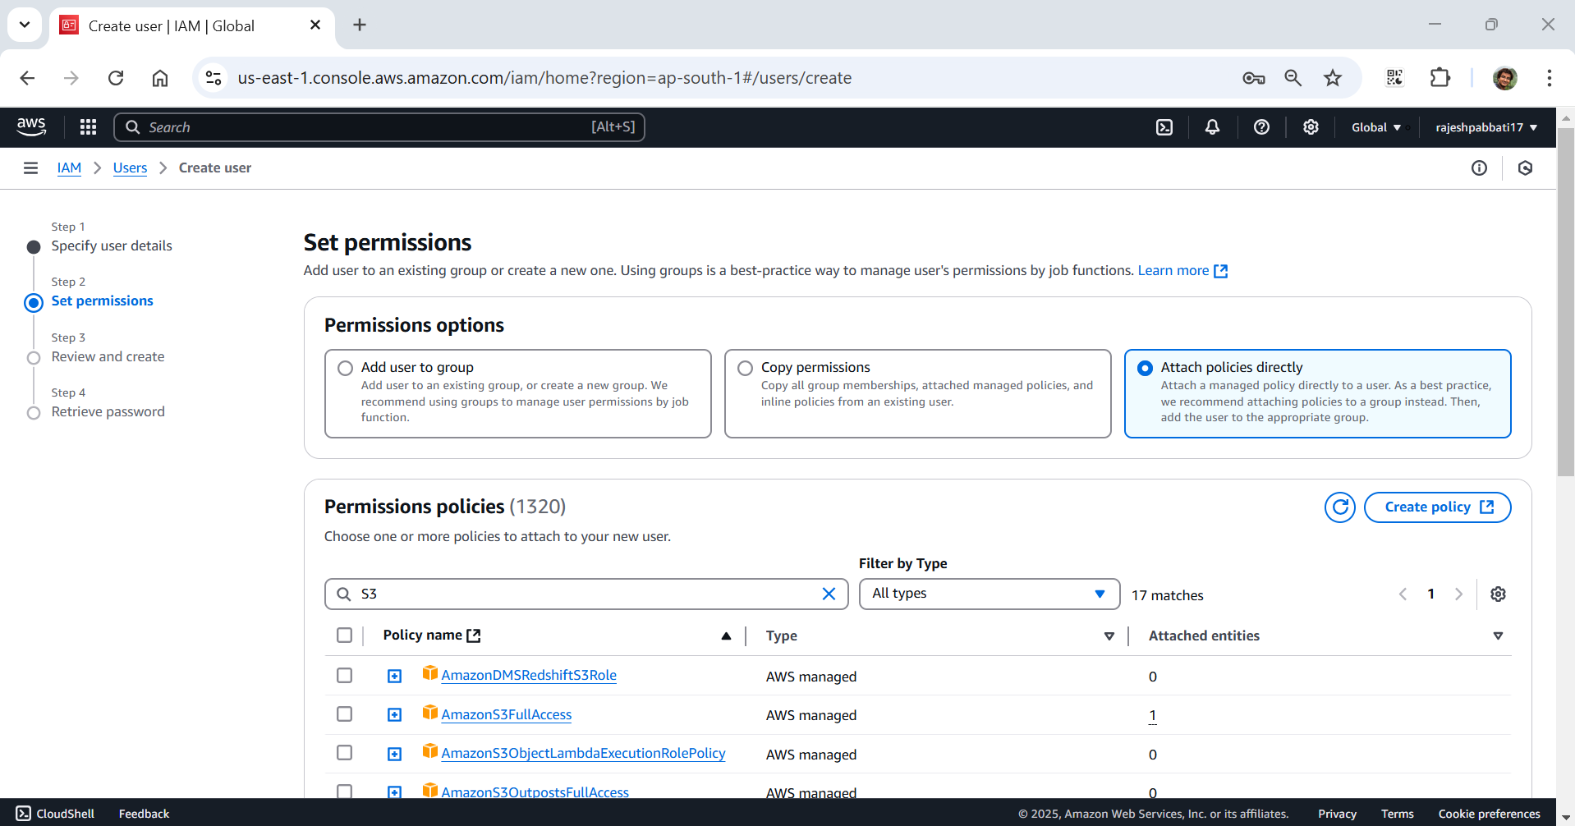

Tick the AmazonS3FullAccess

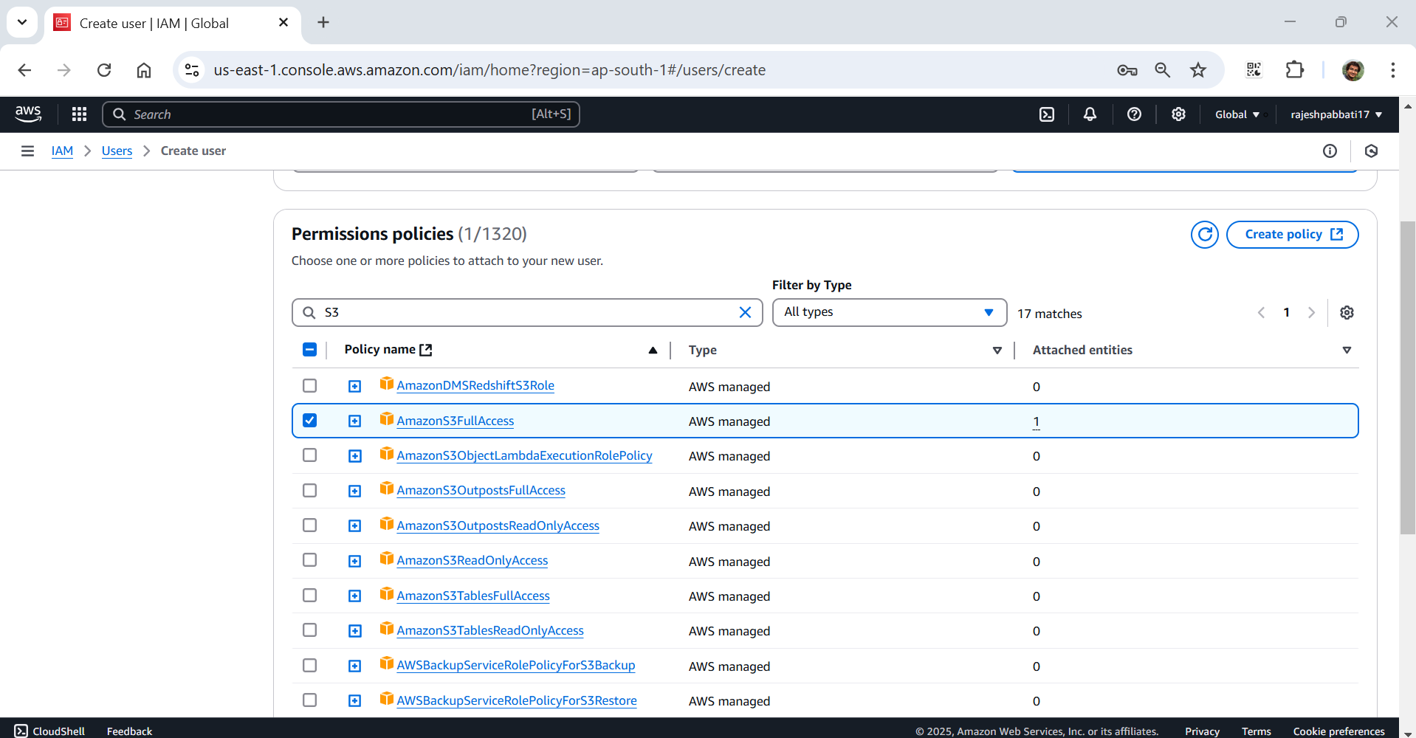

Review and click on create user

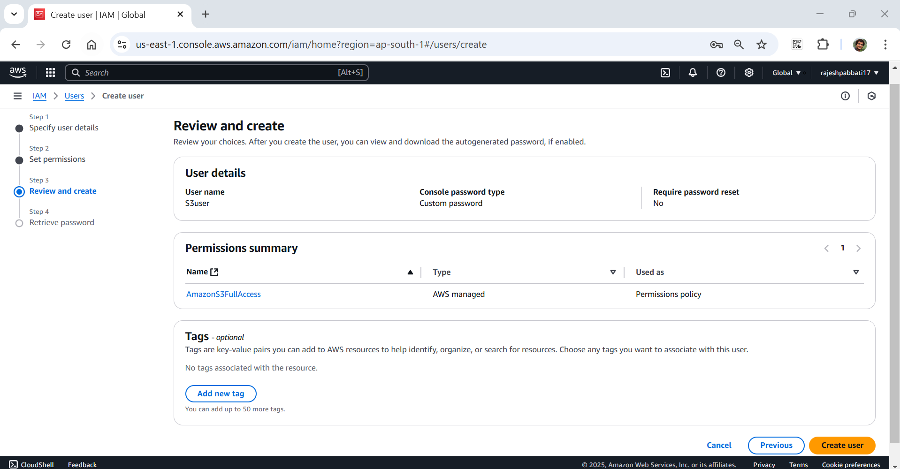

User created successfully will display and download the .csv file by clicking Download .csv file button which contain credentials and console sign-in URL

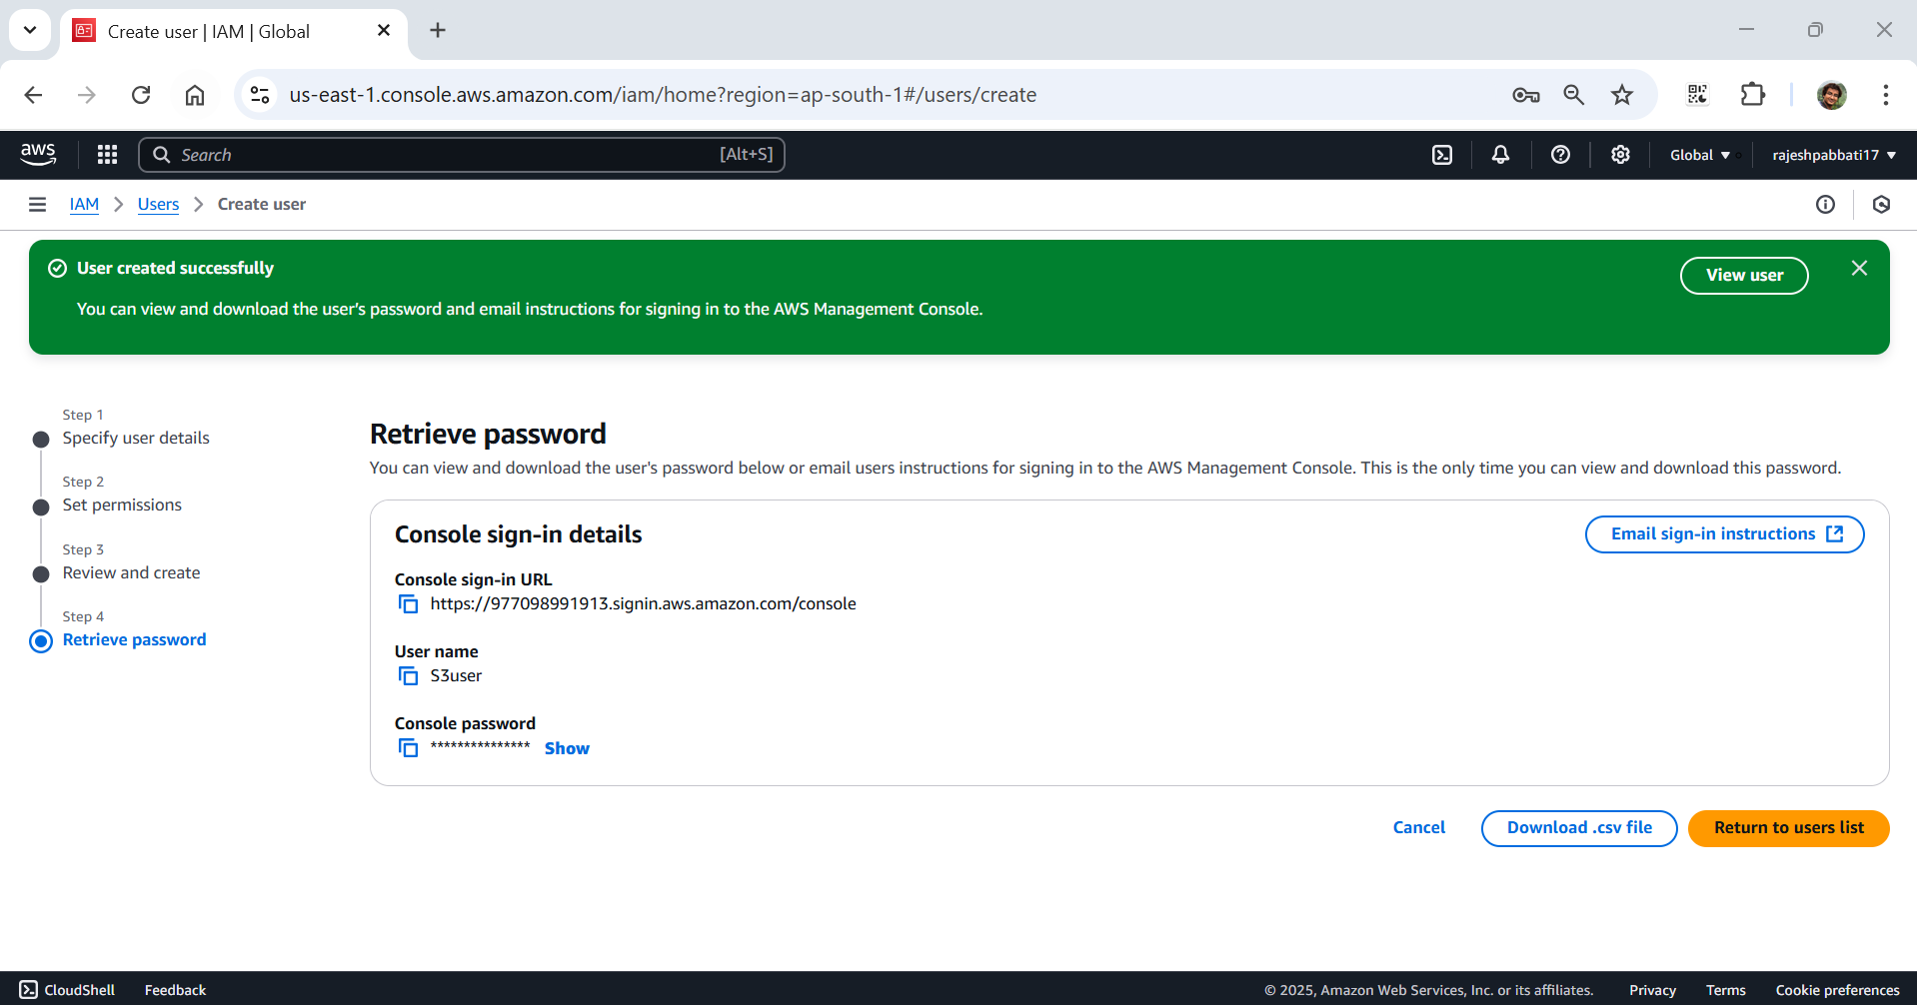

Here S3user will look like

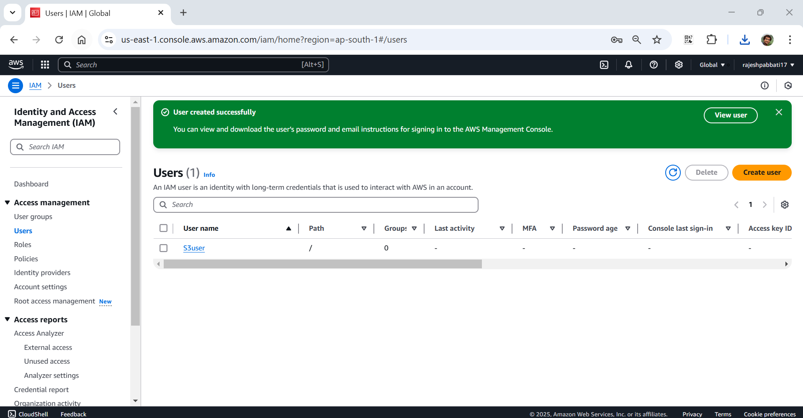

1. Setting up Custom Sign-in URL

Got to IAM dashboard -> users -> Account Alias -> Create

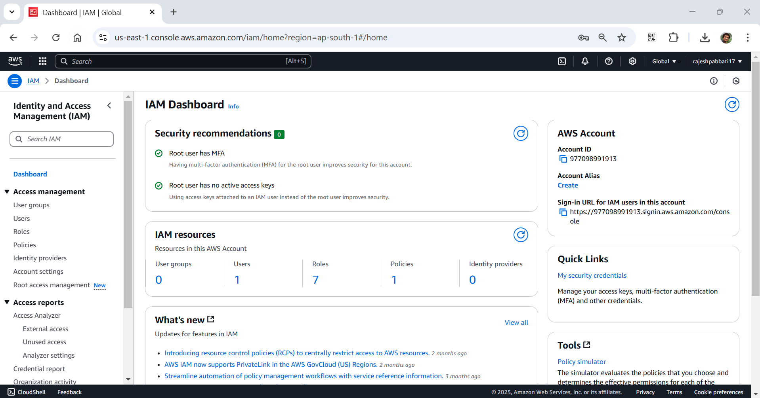

Enter the Preferred alias as s3full and click Create alias

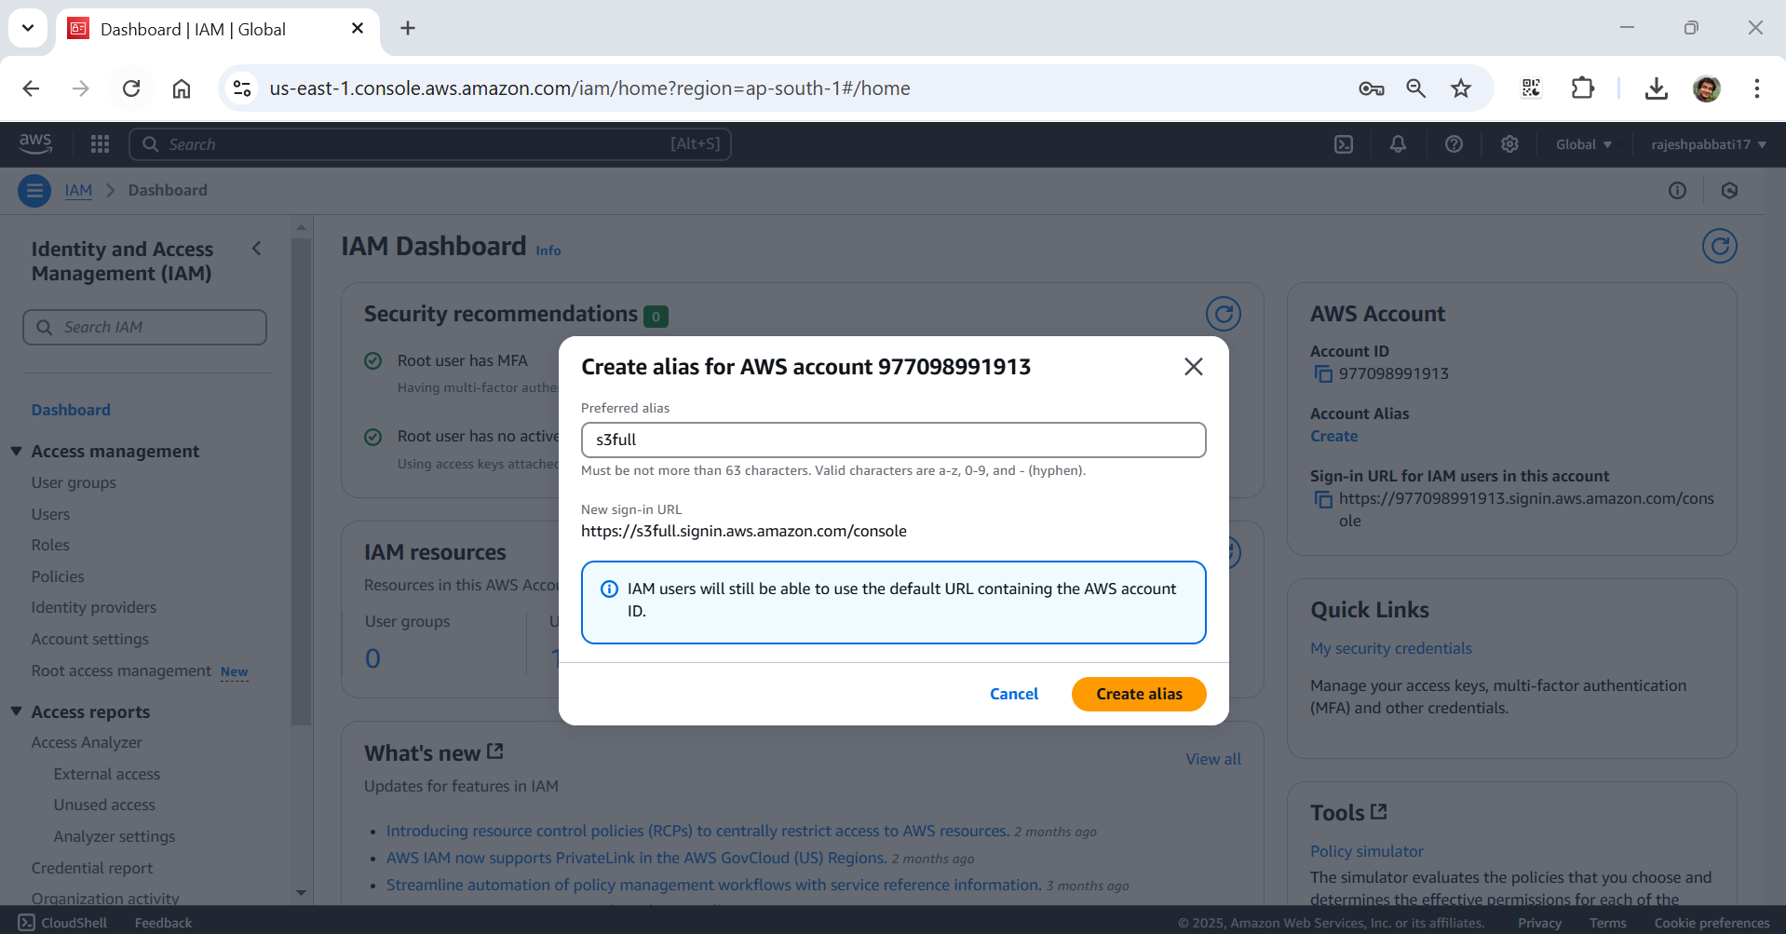

Allias s3full created for this account will be displayed once done

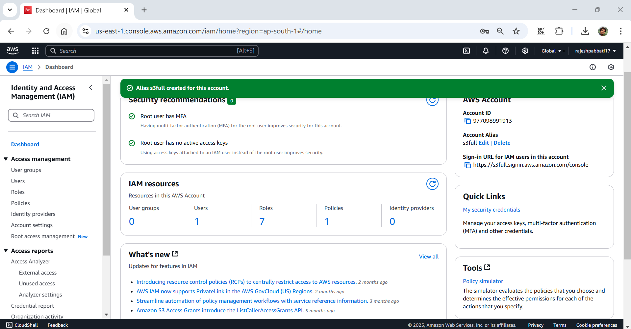

Below is the custom sign-in URL

<https://s3full.signin.aws.amazon.com/console>

1. Setting up MFA

Go to IAM dashboard

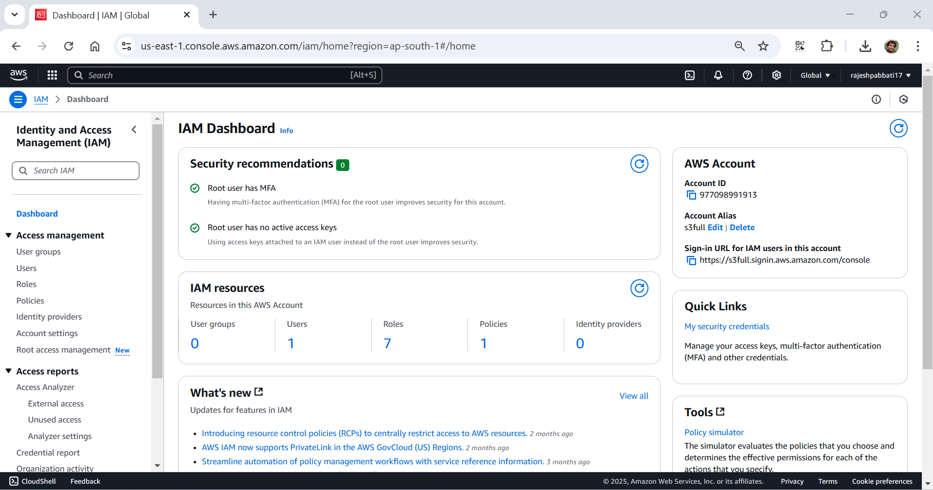

Click on Users -> click on s3user

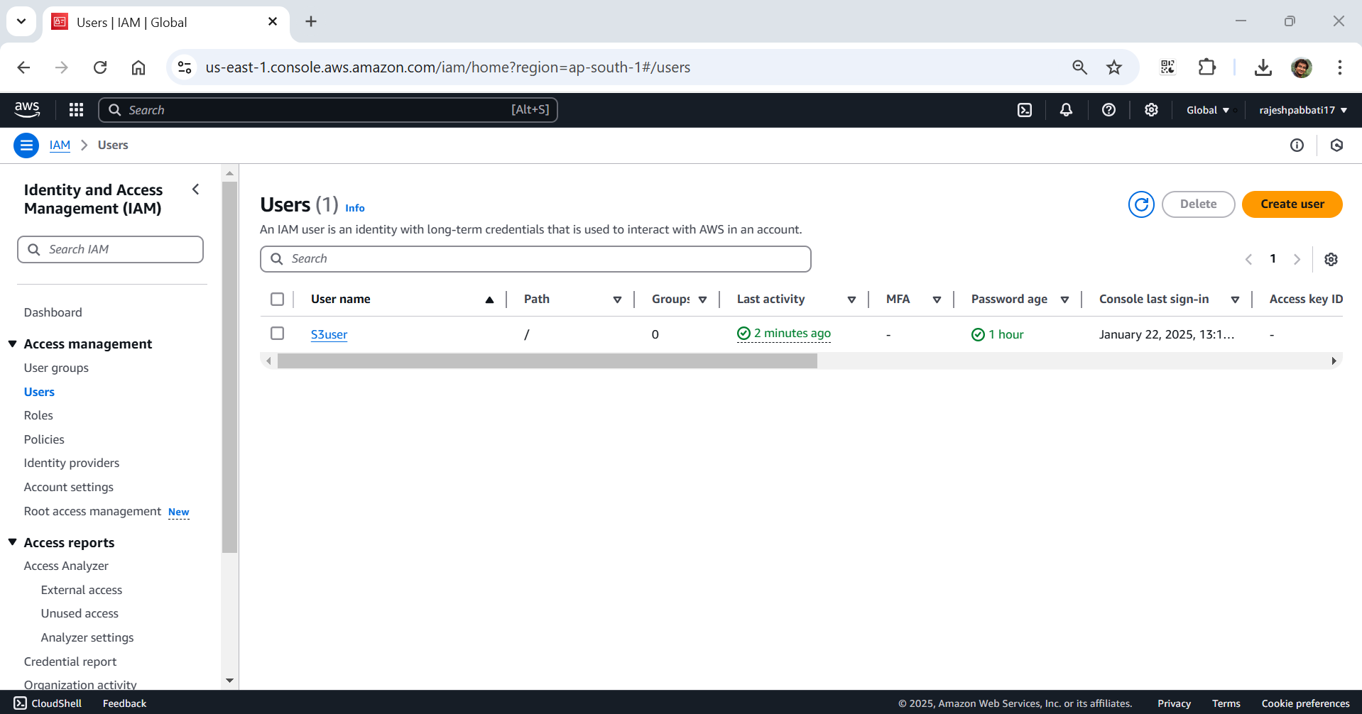

Click on security credentials

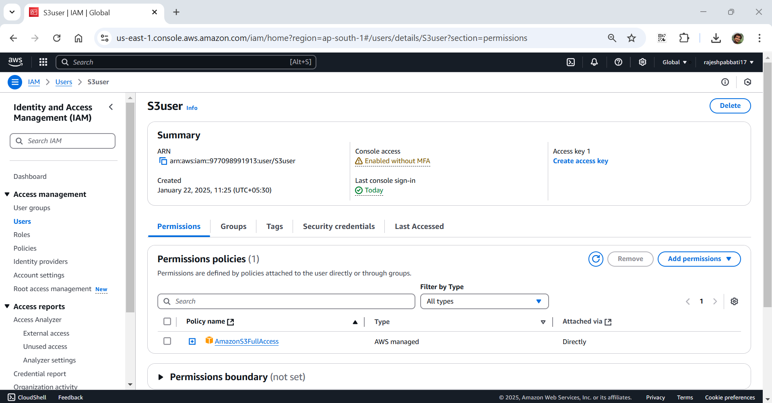

Click on Assign MFA device

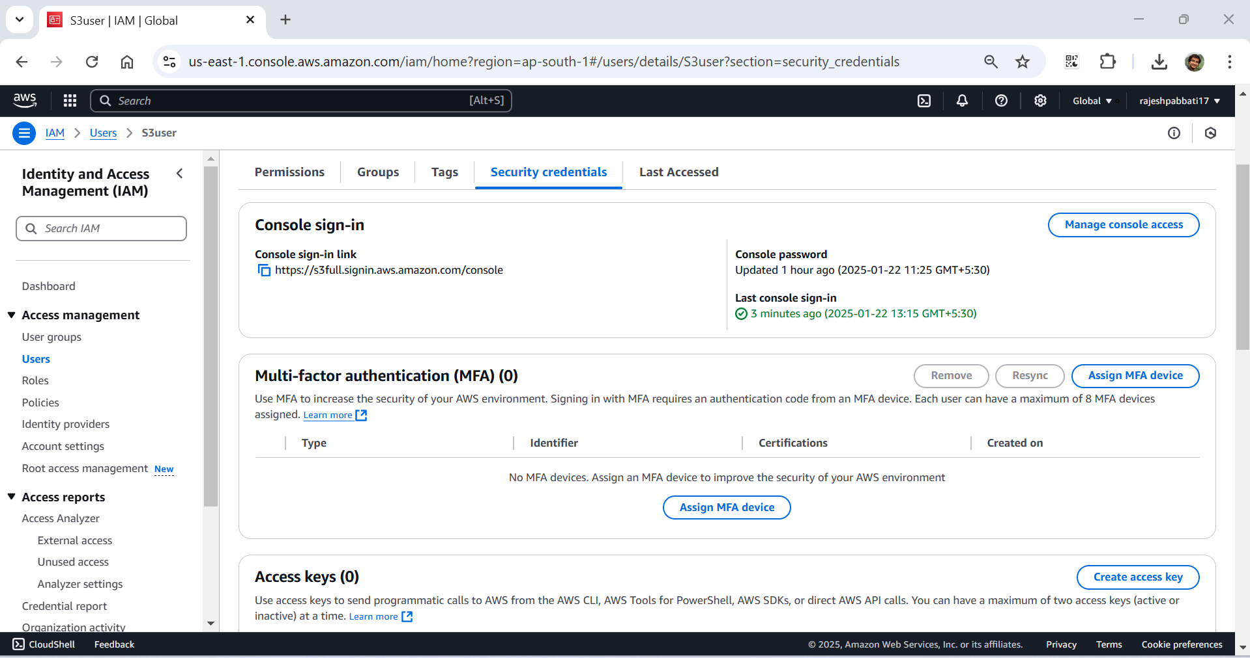

Enter device name

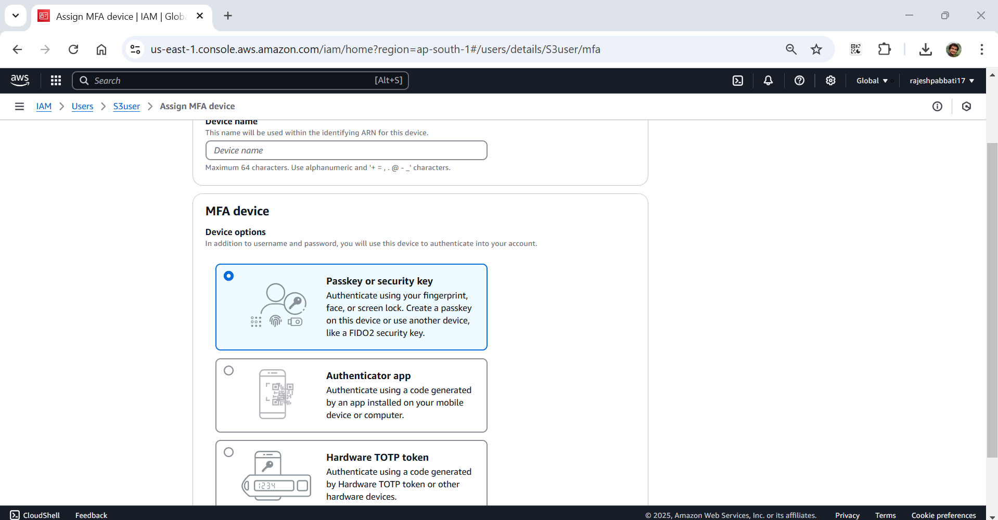

Enter mobile as device name

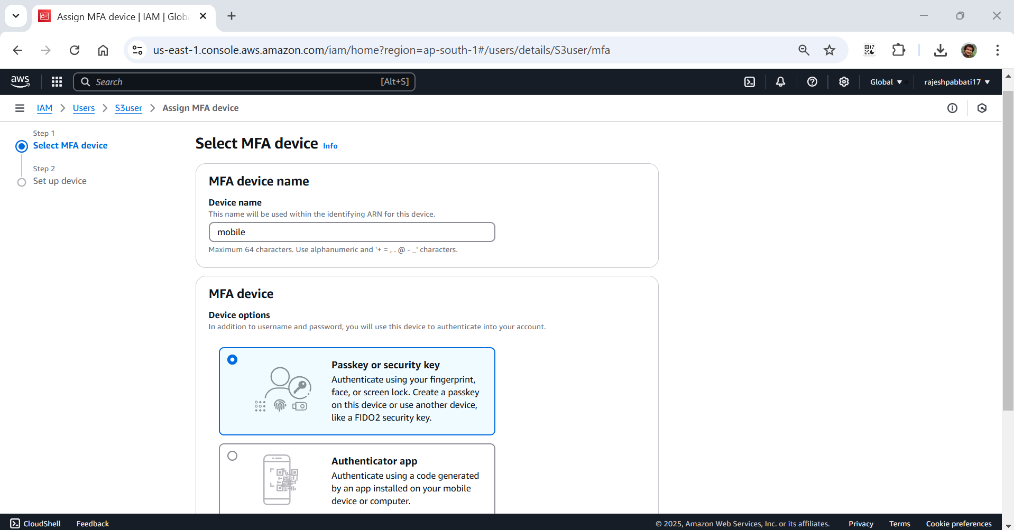

Select Authenticator app

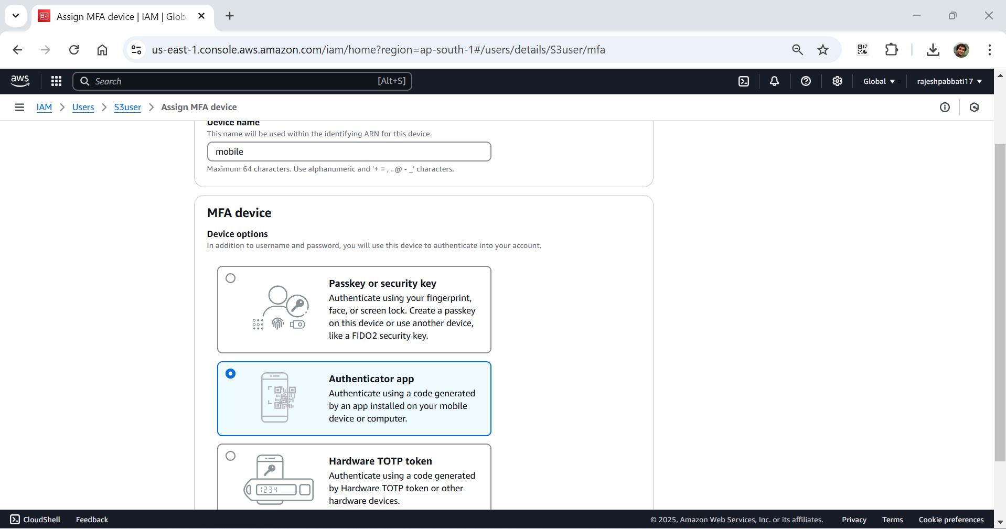

Click on show QR code

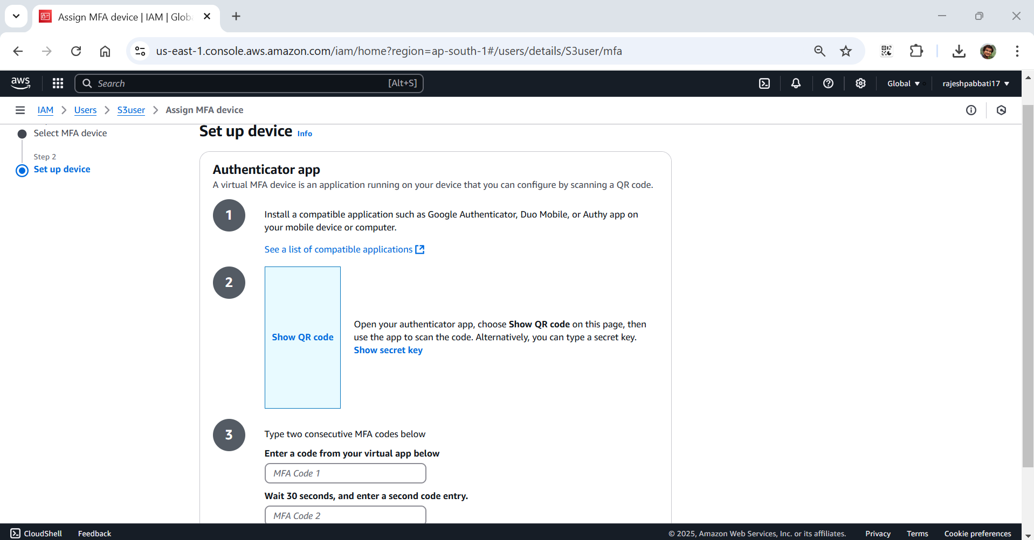

Install Microsoft authenticator app on mobile and open QR code scanner and scan the QR code on laptop AWS console screen

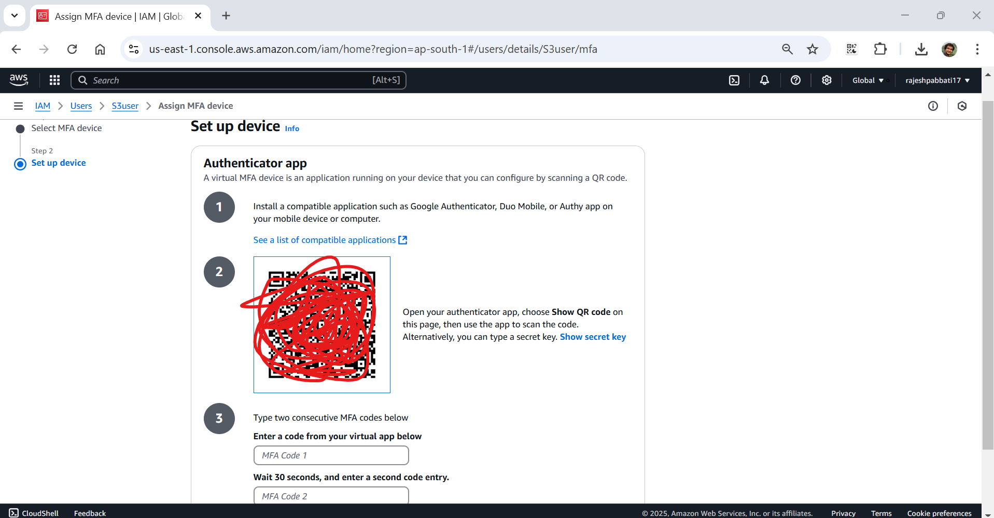

code will display on mobile Microsoft authenticator app enter that code in AWS console and wait for 30 seconds for another code

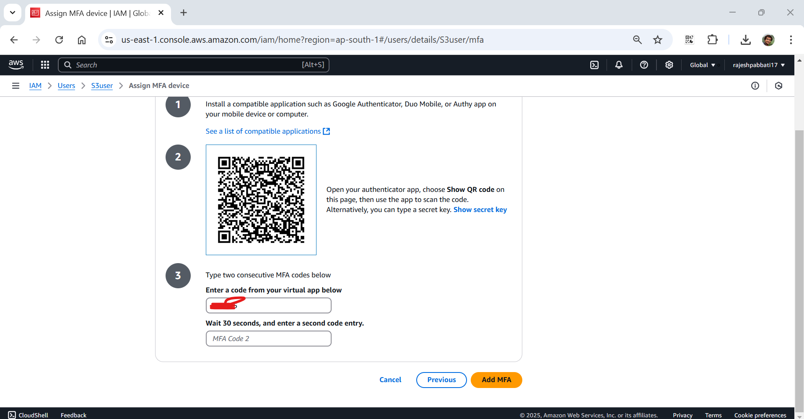

Enter the second also in the AWS console and click Add MFA

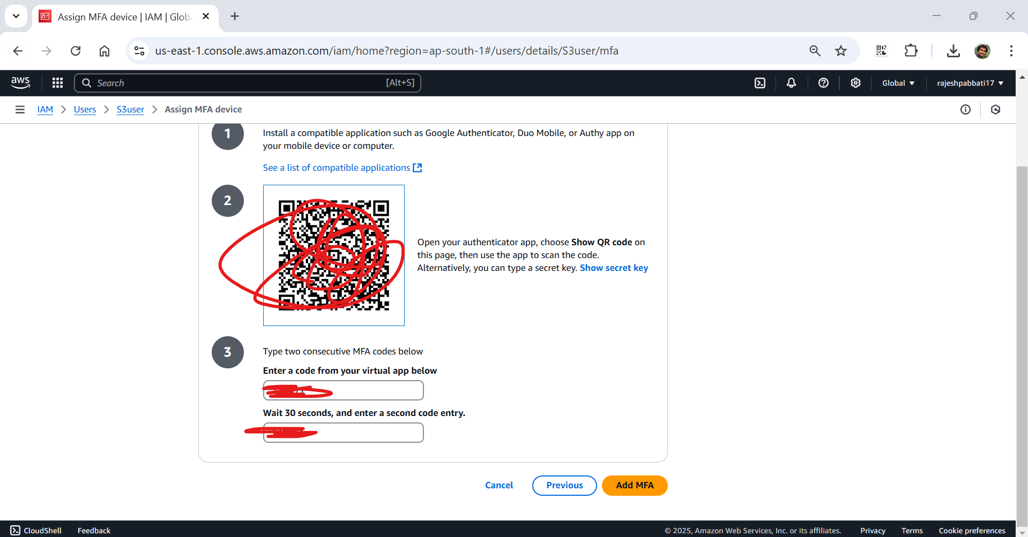

MFA device assigned will display as success

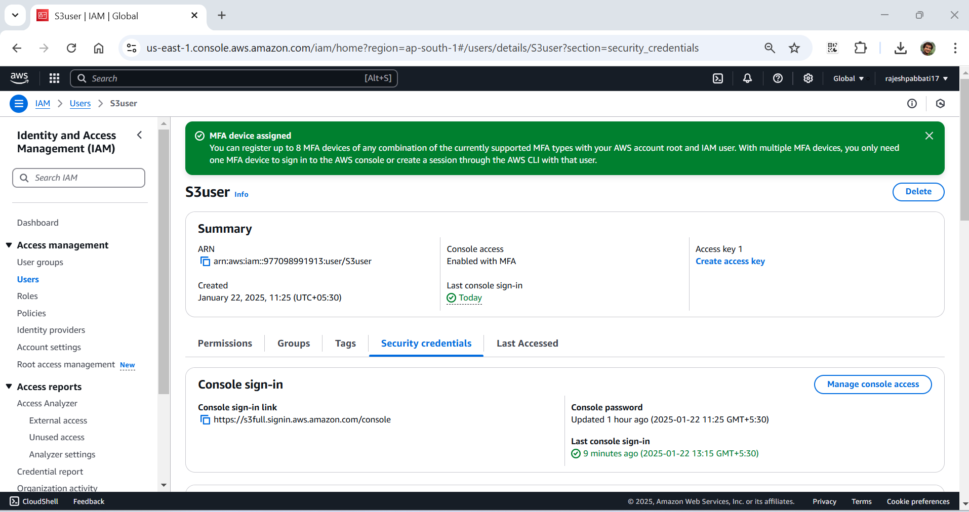

Under MFA device is shown

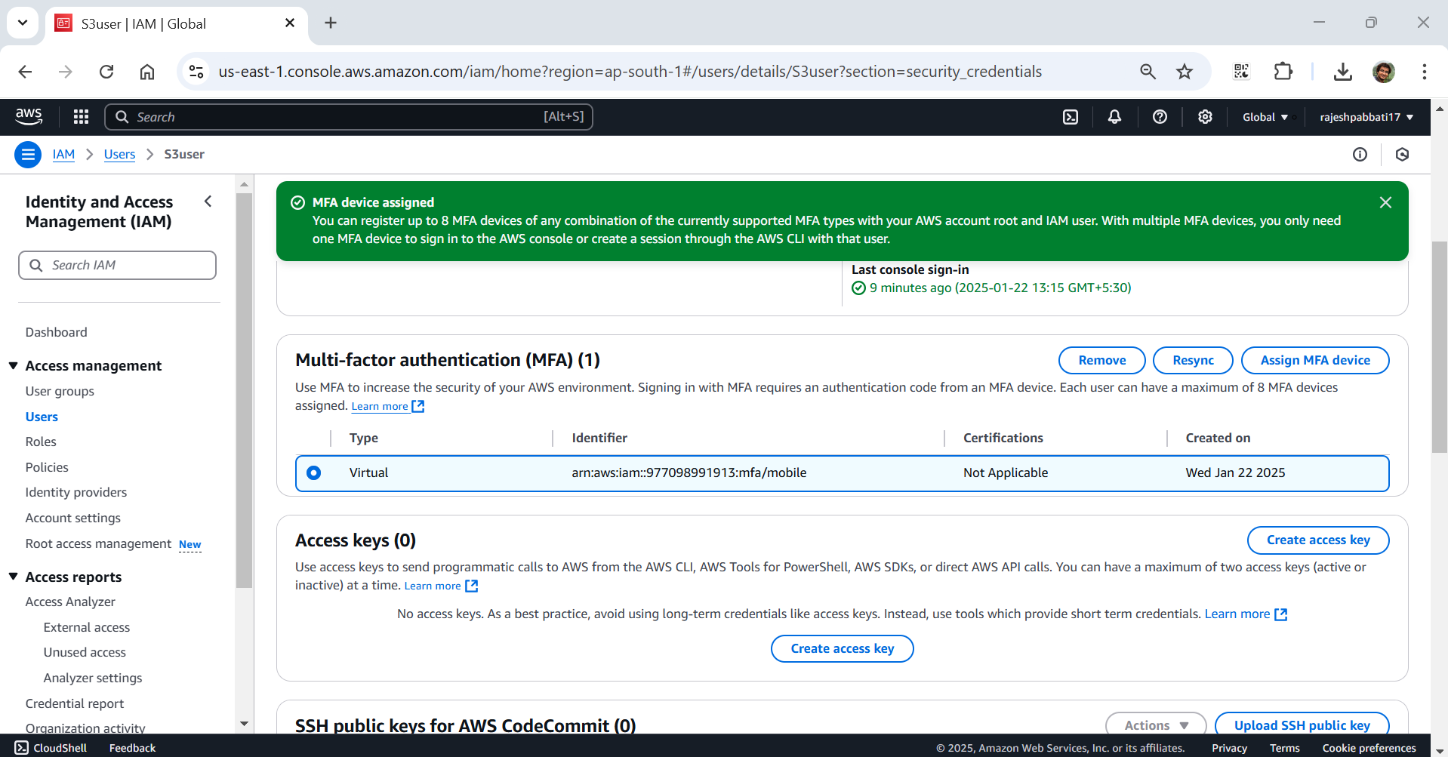

Login with s3full user

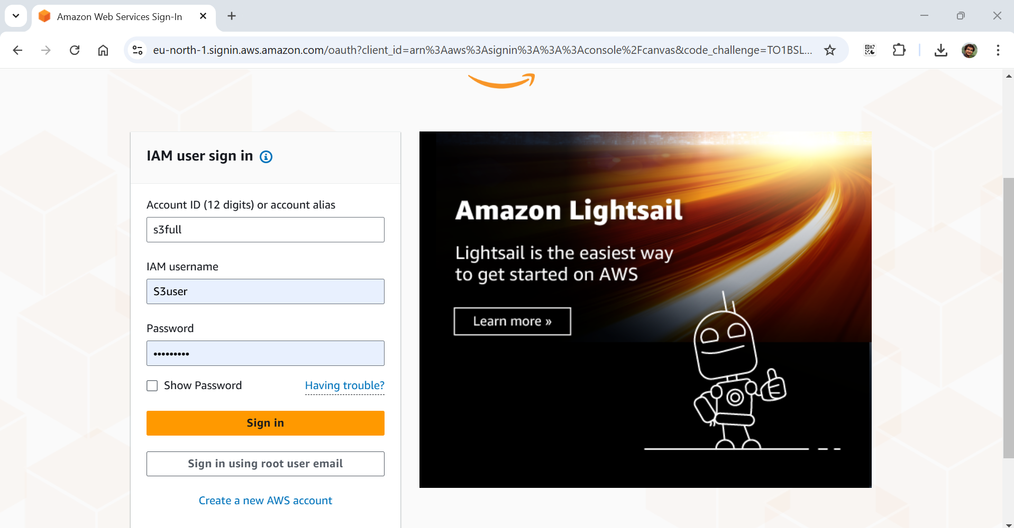

MFA code will come to mobile app

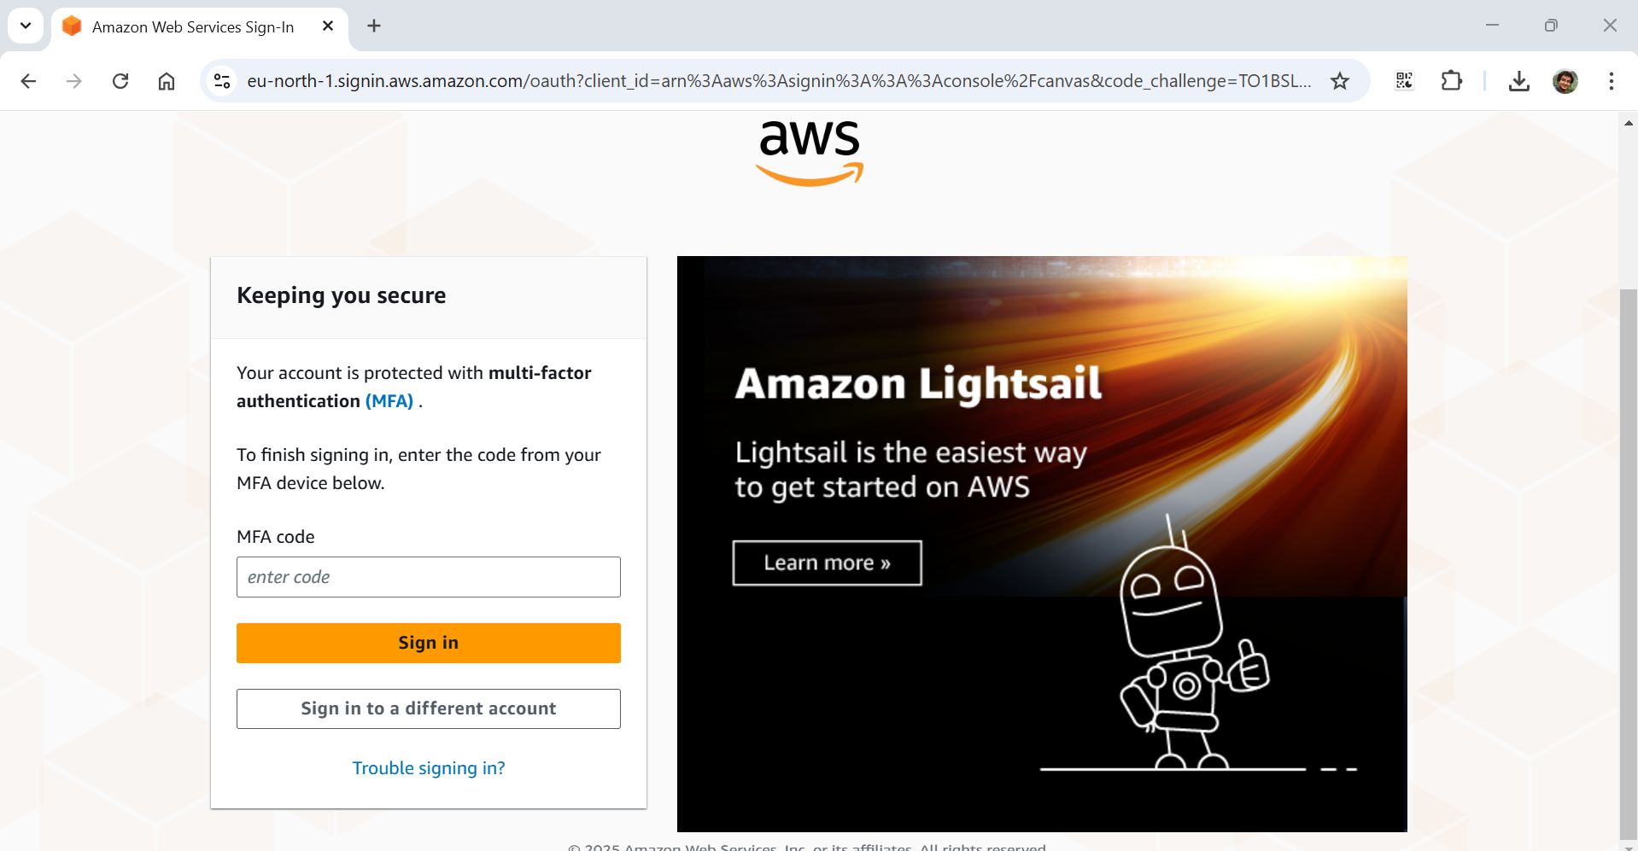

Enter the code and click on sign in

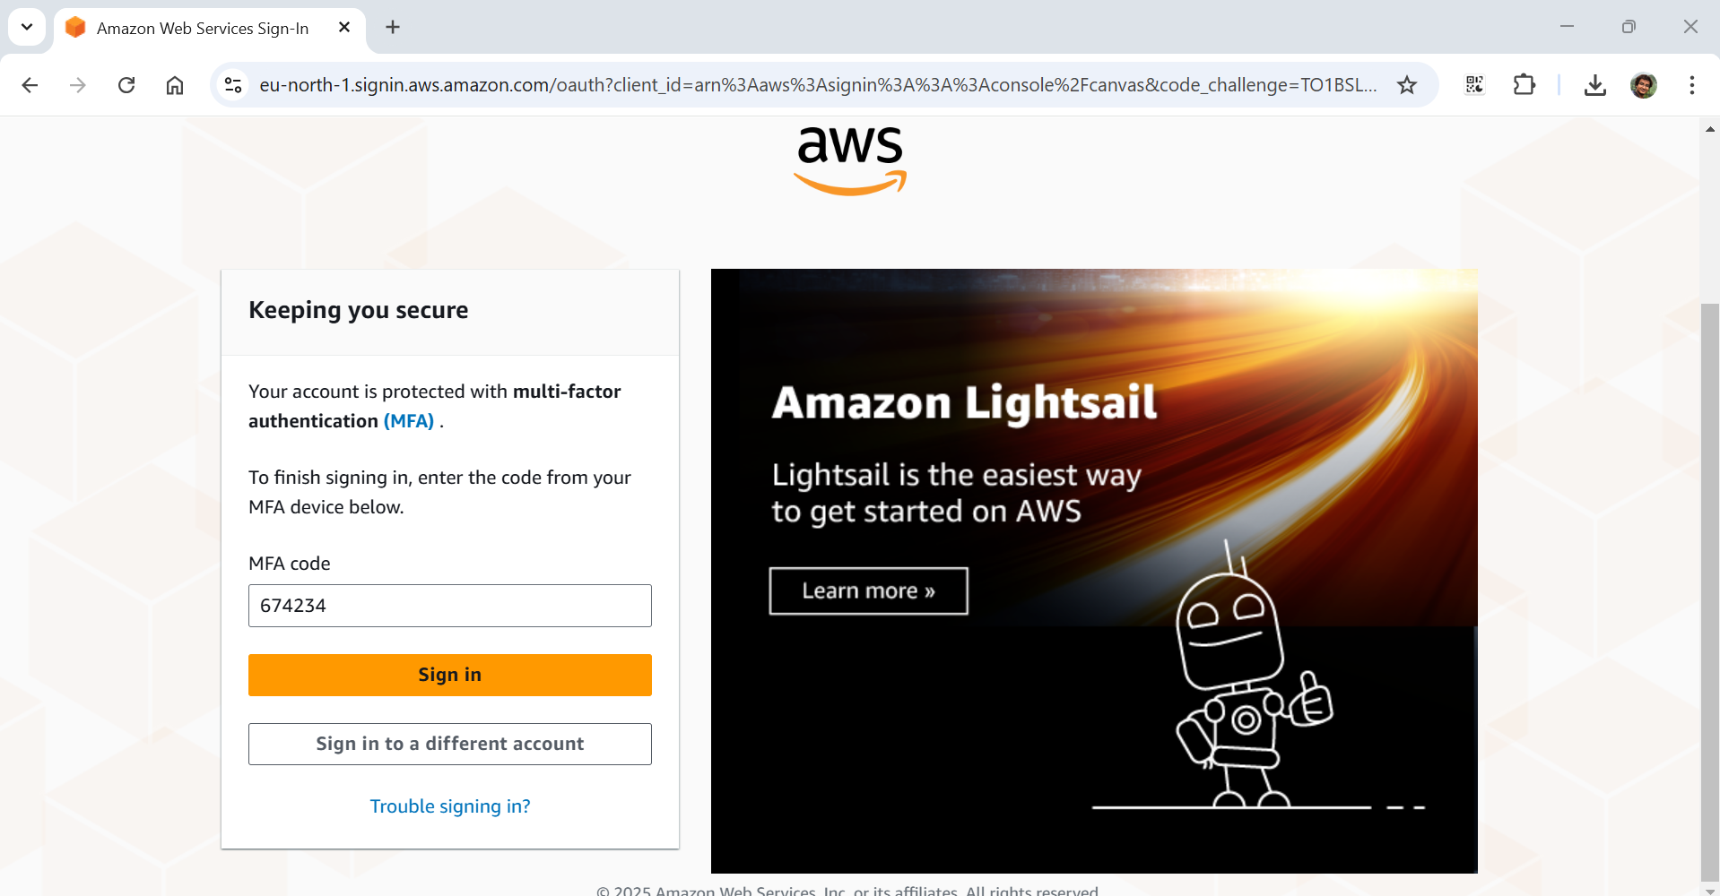

Login successfull

